**Abstract:**

**Feedbacks from ChatGPT with screen short:**

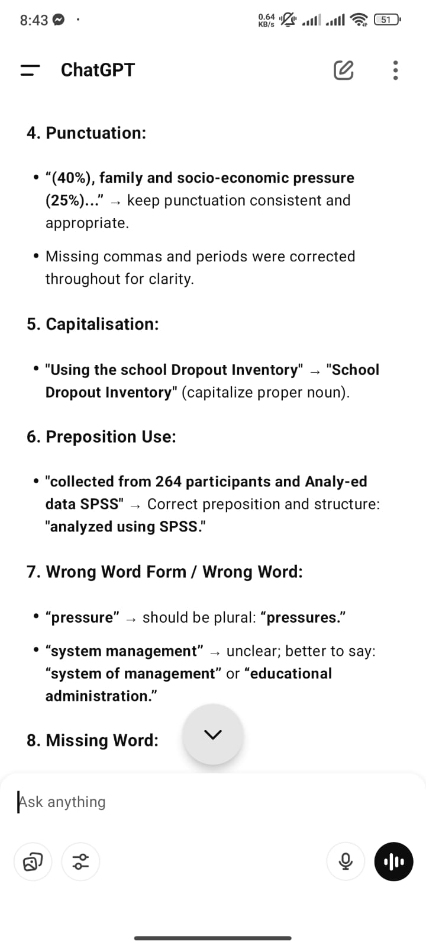

**Revised Abstract part:**

